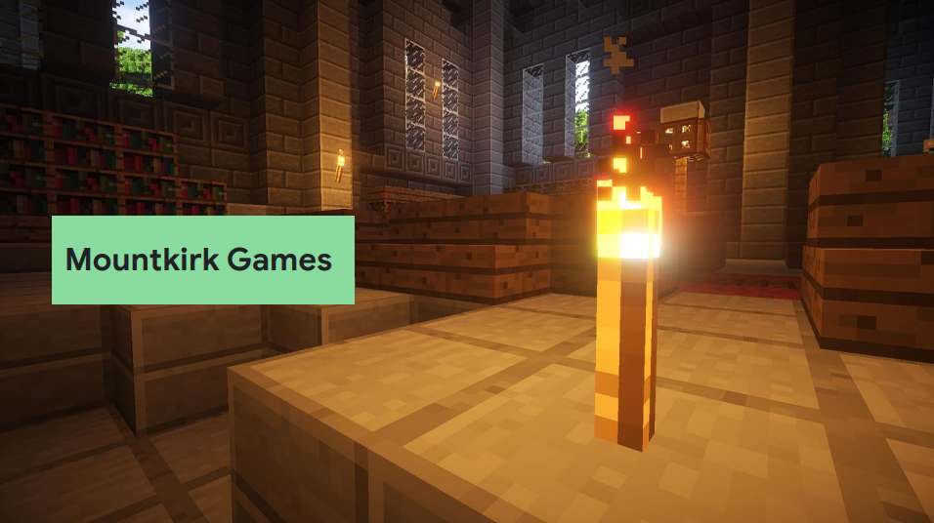

**Business Evaluation**

|  |  |  |
| --- | --- | --- |
| **Online games platform** | **Values** | **Immediate Goals** |
| After initial success with Google Cloud, now want to build all-new games using cloud-native design | ● Analyze player behavior and game telemetry  ● Online session-based multiplayer games  ● Use managed services and pooled resources  ● Minimize cost | ● Support new gaming platforms beyond mobile ● Rapidly iterate on deployments  ● Support hundreds of simultaneous players with global leaderboard |

**Key business assumptions**

|  |  |  |
| --- | --- | --- |
| **Support multiple platforms across multiple regions** | **Need dynamic scaling to minimize latency and to minimize cost** | **Potentially different storage solutions for game itself and analytics** |

**Technical Evaluation**

|  |  |  |
| --- | --- | --- |
| **Existing Environment** | **Technical Watch points** | **Proposed Solution** |
| Existing games migrated to Google Cloud using lift-and-shift VM migrations | Compute  ● New game backend to be Google Kubernetes Engine  ● Need to scale across regions  ● Use GPU processing to render graphics for multi-platform  ● Eventual migration of existing games to new platform | ● Google Kubernetes Engine  ● Global load balancing  ● Cloud GPUs |
| Separate environments for development and testing | Storage  ● New game to using a multi-region cluster for global leaderboard | ● Cloud Spanner with multi-region configuration |
|  | Data ingestion  ● Live metrics from game server  ● Game logs stored in structured files for future analysis | ● Pub/Sub for buffering of live and late data  ● Dataflow for bulk and stream processing  ● BigQuery for storage and analytics; this can also contain the 10 TB historic data |